Test Evidence:
Task 1: data setup
The flowise flow successfully ingested the data into pinecone db index- “oranativajewellery”
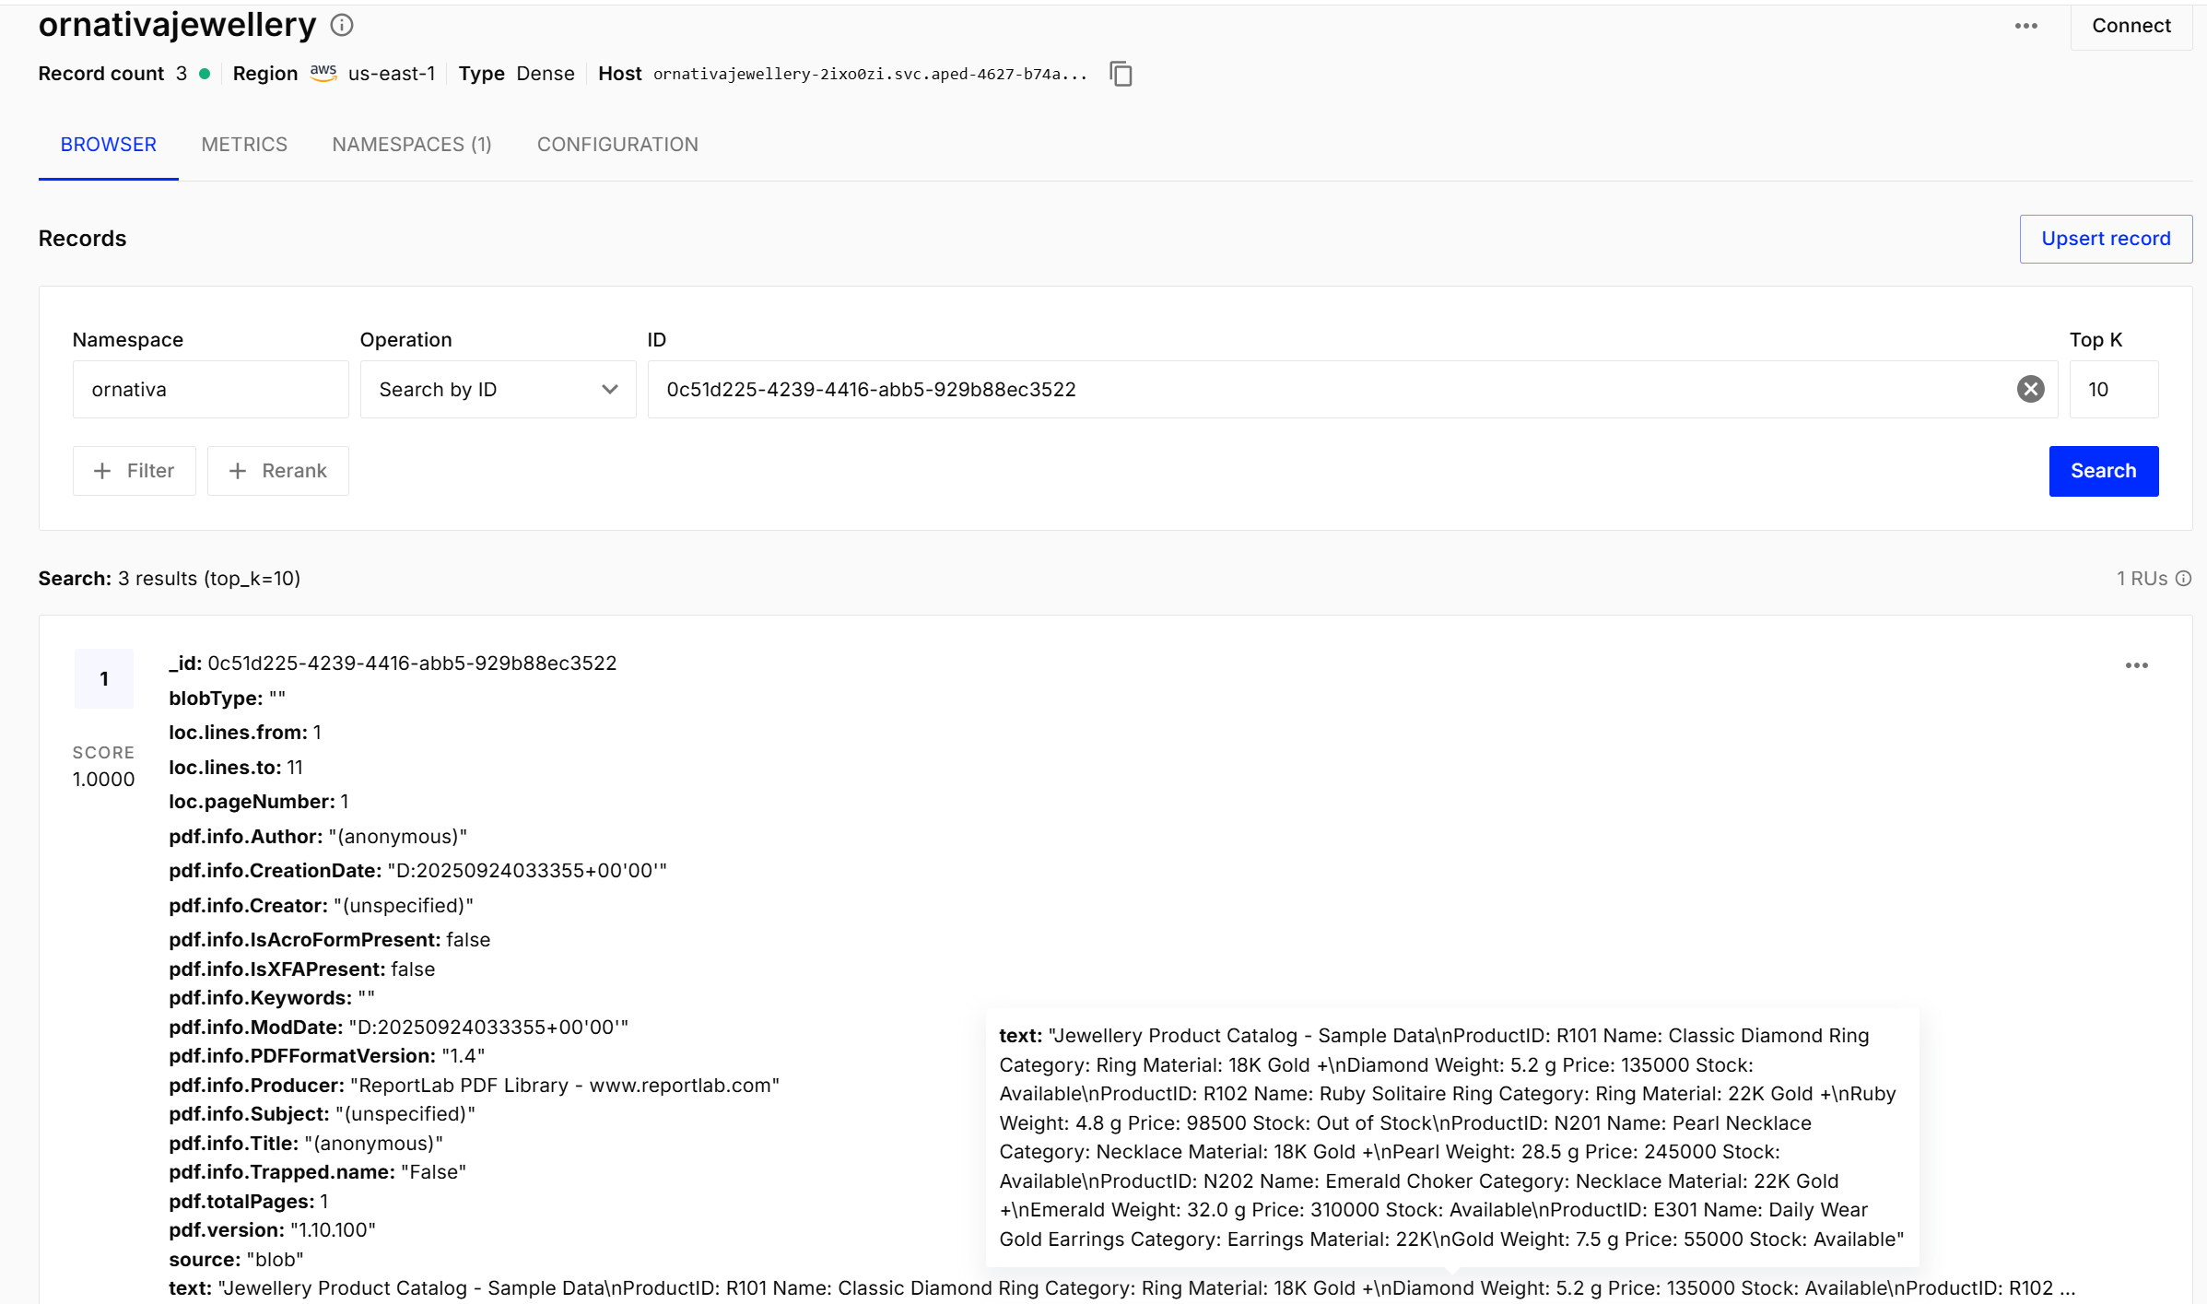

Task 2: create query chain
Deliverable: A working query-response flow that can answer questions
Task 3: Add Conversational memory
Deliverable: A Flowise chatbot that maintains short-term conversation context.
The below screenshots shows these 2 task deliverables, 1st question answering the query and 2nd one answering the follow up question i.e, using buffer memory
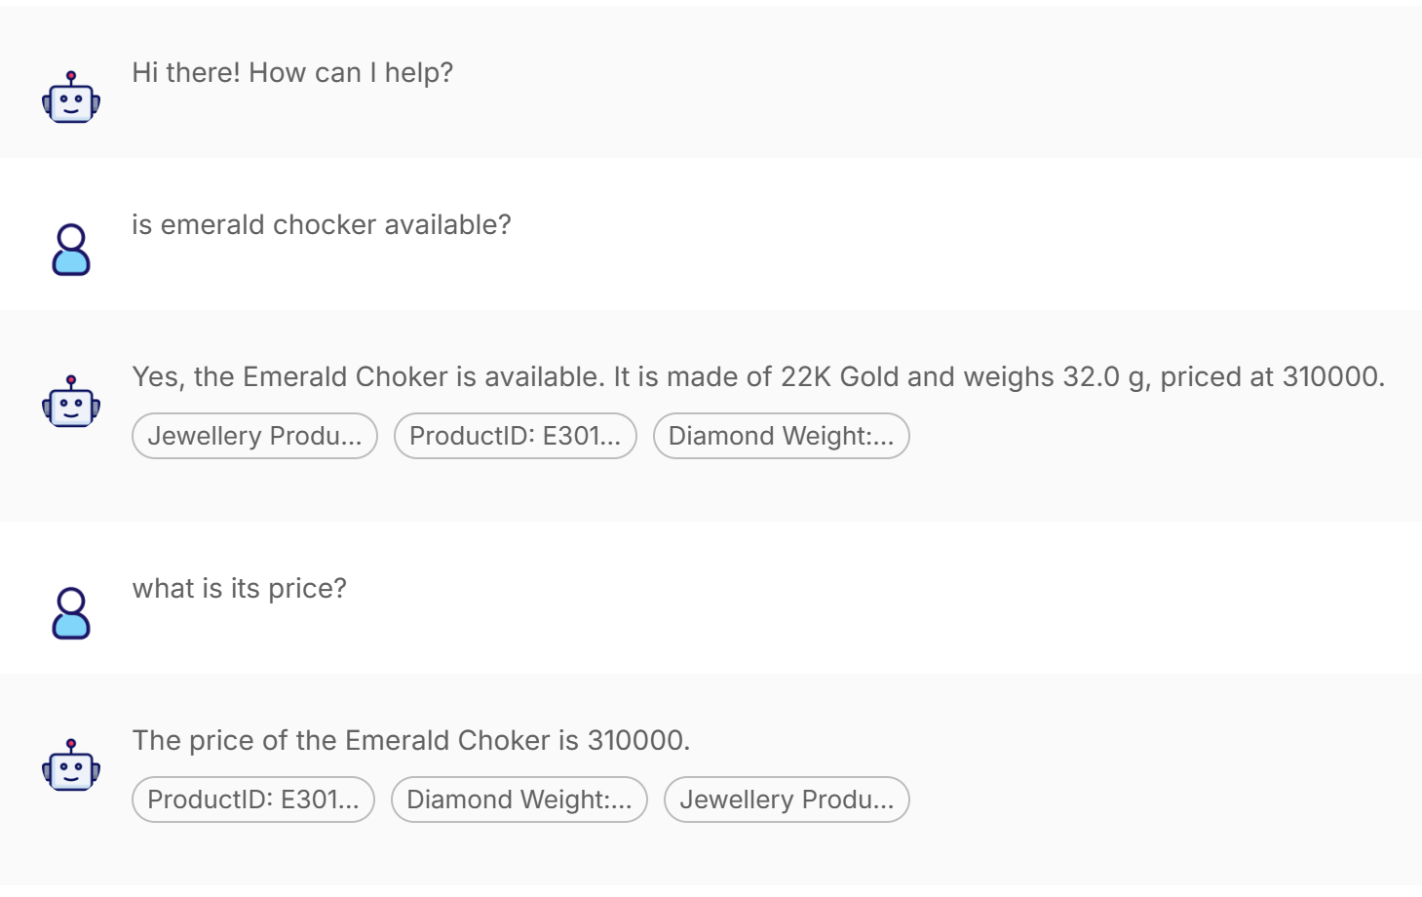
Task 4: Customisation and Testing
Deliverable: Evidence of testing (queries + responses) and out-of-stock handling with an appropriate alternative suggestion (based on the catalogue).
The below outputs shows the responses on the material based questions, the product that is not part of the catalogue, the bot not giving false information to the questions out of its context, when asked about biryani it responded saying “I’m sorry I don’t have information about that in the catalogue”
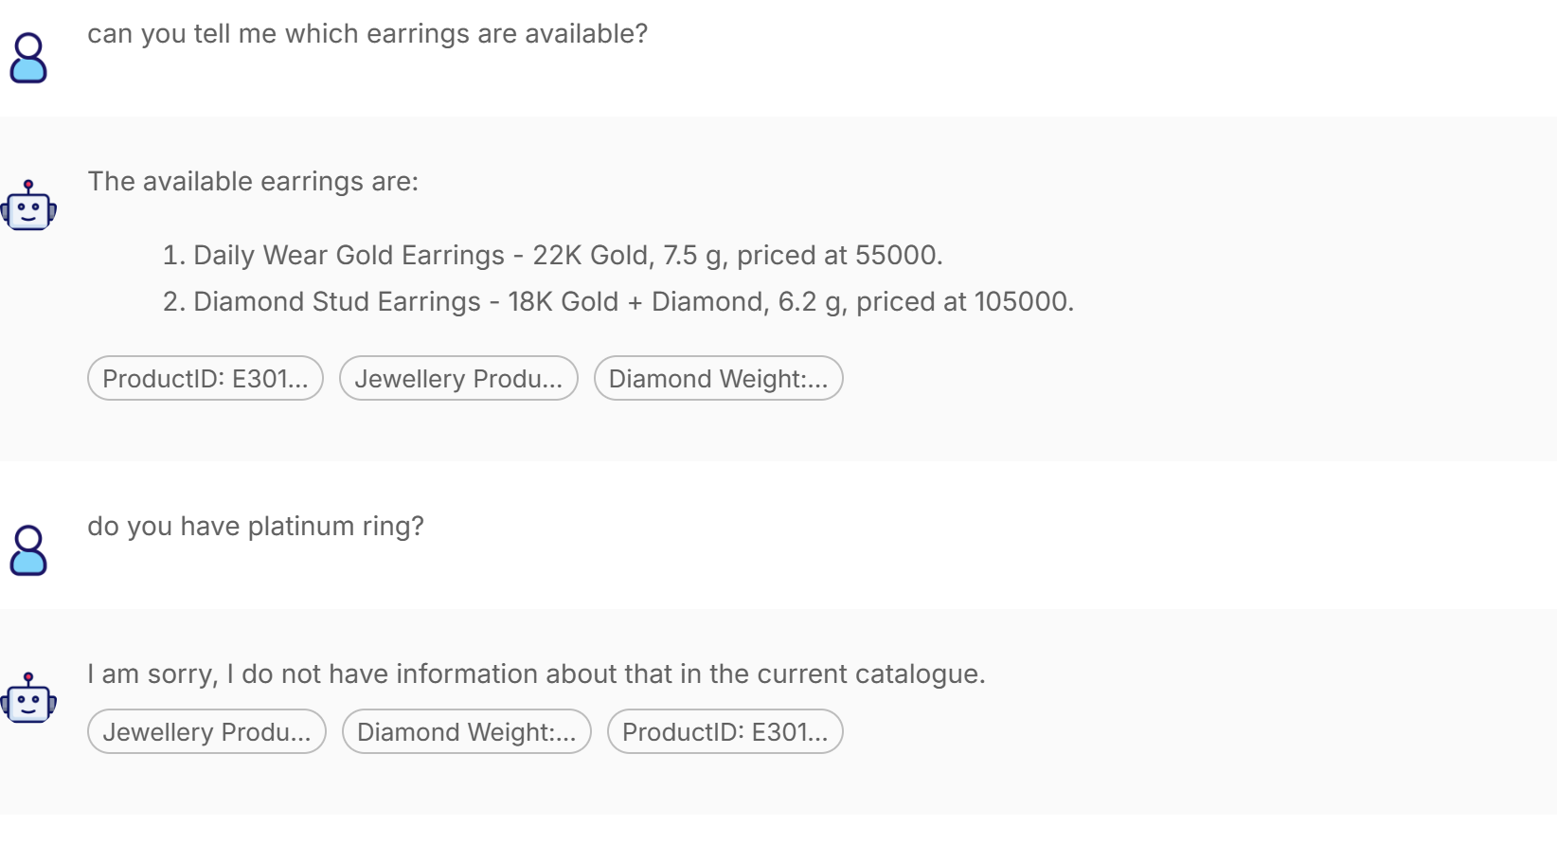
Out of stock is handled gracefully by suggesting an alternative product to the user.

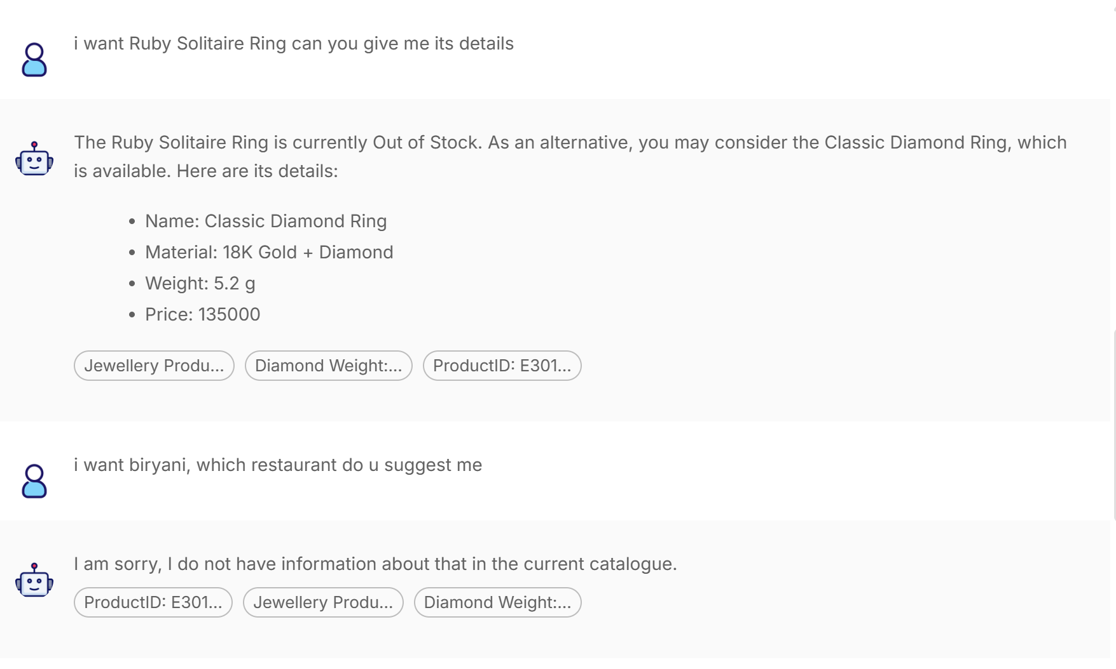
This shows all the available items that are 22k gold, showing correct retrieval.
